Contribution to the LEO Network: Pine Siskin Salmonellosis Outbreak

Colin K. J. Park (362783)
School of Environment and Sustainability, Royal Roads University
EECO586: The Biosphere and Sustainability
Professor David Oswald
September 24, 2023
Word Count: 507

Contribution to the LEO Network: Pine Siskin Salmonellosis Outbreak
In the winter of 2021, I encountered many pine siskin (Spinus pinus) carcasses. Observing multiple dead birds is an indication that there may be a disease outbreak occurring. I observed many small bird carcasses in my neighbourhood, including three pine siskin carcasses in one day.
I selected this observation because it was a sudden environmental event supported by a media response that described the situation. Three potential consults for my observation are Dr. Russ Dawson, Professor and Avian Ecologist at the University of Northern BC; Andrea Wallace, Manager of Wild Animal Welfare at the BC SPCA; and Matt Wallace, Organizer of the Christmas Bird Count with Nature Calgary.
The pine siskin is a small songbird from the finch family with inconspicuous brown streaks and flashes of yellow on their wings and tail. When foraging naturally, the birds spread out to feed on seeds from pine, cedar, larch, spruce, alder, birch, and maple trees (Cornel, 2023). When foraging naturally, they do not congregate at a food source; however, pine siskins also congregate at bird feeders (Cornel, 2023; Del-Colle, 2020; Marlow, 2021) as shown in Figure 1.
Pine siskins are native to and widely distributed throughout North America (Cornel, 2023) as shown in Figure 2; however, their abundance varies due to migratory irruptions. Pine siskins may be dense in one area yet be sparse in the same area the next year (Strong et al, 2015). Strong et al. (2015) found that pine siskins migrate in response to a north-south pattern or an east-west pattern in response to climate variability. Specifically, precipitation and moisture may influence desirable seed production in one area and not another.

Figure 1
Multiple Pine Siskins at a Bird Feeder
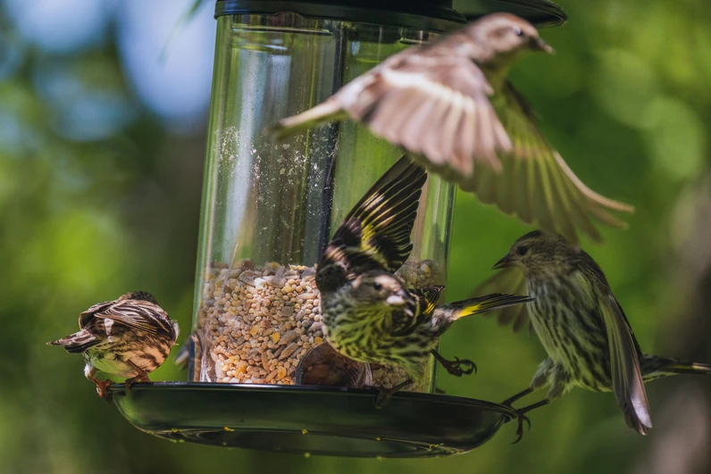
From Del-Colle (2020, https://www.audubon.org/news/-pine-siskin-finch-irruption-fall-2020)
Figure 2
Migratory Patterns of Pine Siskins
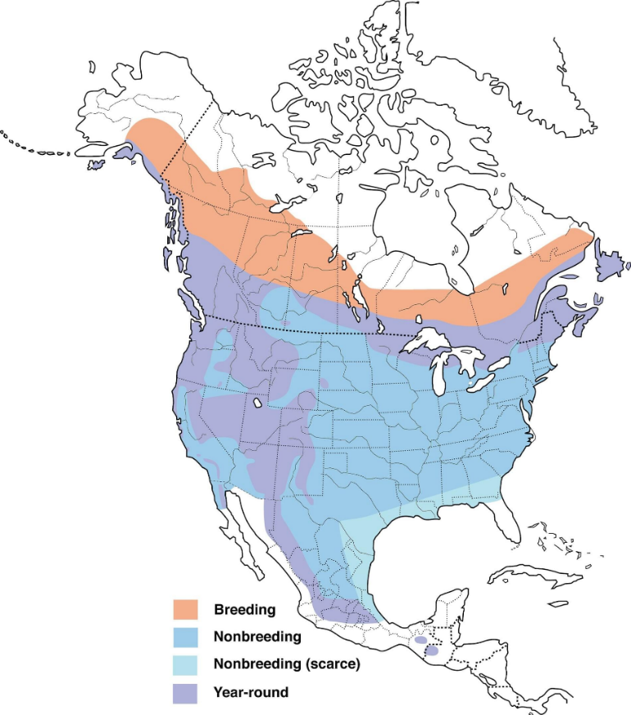
From Cornell Lab of Ornithology (2023, https://celebrateurbanbirds.org/learn/birds/focal-species/pine-siskin/)
Across the United States, pine siskins have been affected by salmonellosis, a non-specific disease caused by the salmonella bacteria (Machemer, 2021; Marlow, 2021). Birds are vectors of many zoonotic diseases, including salmonellosis (Michel et al., 2020) which is spread through feces (Machemer, 2021). The United States Centre for Disease Control (2021) documented a human epidemic of salmonellosis from December 2020 to April 2021 and associated this human epidemic with pine siskins and bird feeders.
The observed outbreak may be associated with the intersection of three unusual phenomena, an increased population (Del-Colle, 2020; Machemer, 2021), a migratory irruption to a populated area, and the increased use of bird feeders during the COVID-19 pandemic lockdown. Populations were well above historical numbers (Del-Colle, 2020; Machemer, 2021). Del-Colle (2020) hypothesized that a lack of food in Canada’s boreal forest caused the pine siskins to migrate south during the autumn of 2020. Finally, Pike (2020) and Marlow (2021) suggested birding was a popular activity during the COVID-19 lockdown because it was a safe outdoor activity that people could do from home. Unfortunately, the birdfeeders were fomites for the transmission of salmonella among birds. Schaper et al. (2021) found that an increased population or congregations around contaminated bird feeders will increase the threat of disease. In response, wildlife professionals asked the public to temporarily take down their bird feeders and bird baths.

References
Del-Colle, A. (2020, October 23). Pine siskins have taken over the country: From coast to coast, the species has irrupted in astounding numbers. Audubon. https://www.audubon.org/news/-pine-siskin-finch-irruption-fall-2020
Centres for Disease Control and Prevention [CDC]. (2021, May 29). Salmonella: Investigation details. Centres for Disease Control and Prevention. https://www.cdc.gov/salmonella/typhimurium-04-21/details.html
Cornel Lab of Ornithology [Cornel]. (2023). Celebrate urban birds: Pine Siskin. https://celebrateurbanbirds.org/learn/birds/focal-species/pine-siskin/
eBird. (2023). Pine Siskin. https://ebird.org/species/pinsis
Marlow, K. (2021, January 25). Wildlife rescue group says bird feeders could be spreading bacterial infection among songbirds. CBC News. https://www.cbc.ca/news/canada/british-columbia/pine-siskin-salmonella-1.5862728
Machemer, T. (2021, March 11). Songbirds are spreading a deadly disease at birdfeeders. Smithsonian Magazine. https://www.smithsonianmag.com/smart-news/songbirds-are-spreading-deadly-disease-birdfeeders-180977222/
Michel, N., Whelan, C. J., & Verutes, G. M. (2020). Ecosystem services provided by Neotropical birds. The Condor, 122(3). https://doi.org/10.1093/condor/duaa022
Pike, H. (2020). Birding takes off during pandemic as younger demographic flock to watch fowl. CBC News. https://www.cbc.ca/news/canada/calgary/calgary-birding-pandemic-trends-1.5830734
Schaper, L., Hutton, P., & McGraw, K. J., (2021). Bird-feeder cleaning lowers disease severity in rural but not urban birds. Scientific Reports, 11(1). https://doi.org/10.1038/s41598-021-92117-y

