Velella velella standings linked to climate change in Tofino, British Columbia
Local Environmental Observer (LEO) Network

Meghan Ostrum
Royal Roads University
EECO 586: The Biosphere and Sustainability
David Oswald
April 19, 2020

Observation
On a recent family vacation, stranded Velella velella were observed on beaches near Tofino, British Columbia. Figure 1 shows similar strandings. Velella velella strandings were once rare and now an annual occurrence beginning in 2005 (Bailey, 2018). They are typically found in warm waters and not in the waters of the Canadian West Coast (Bailey, 2018). Recent sightings are shown in Figure 2.
Figure 1. Velella velella on a beach near Tofino, British Columbia (Lovgreen, 2016).
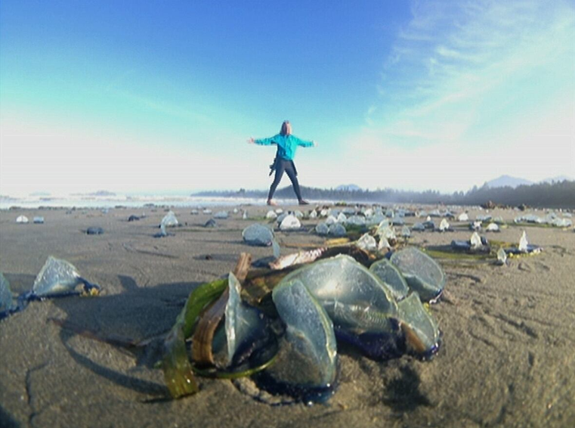

Figure 2. Velella velella sightings in 2016 (jellywatch.org).
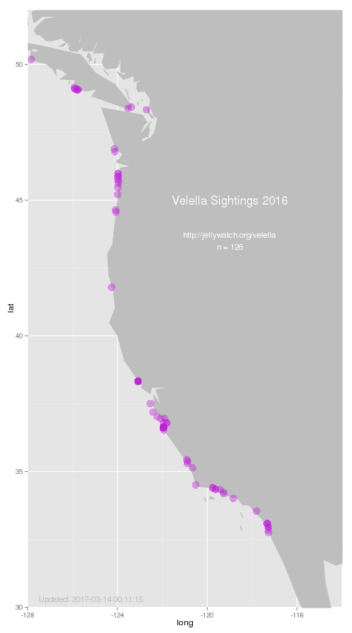

Velella velella are small hydrozoans which consist of hundreds of polyps (Bailey, 2018). They have a stiff sail on top made from chitin with air-filled chambers (Fretwell and Starzomski, 2014). These air chambers allow them to float on ocean surface water where they can blow onto beaches (Fretwell and Starzomski, 2014). If they are not able to return to the ocean with the tide, they can die within a few hours (Fretwell and Starzomski, 2014). Their life cycle is shown in Figure 3.
Figure 3. Velella velella life cycle (jellywatch.org).
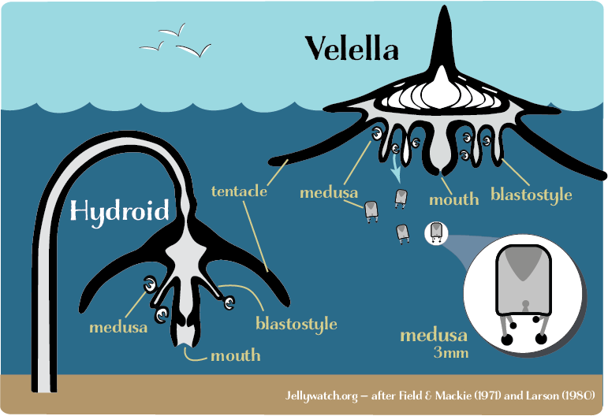
Velella velella feed on small fish, invertebrate eggs, and crustaceans (Fretwell and Starzomski, 2014). Predators of this species include the sunfish (Mola mola), local mollusks, and the violet slug (Fretwell and Starzomski, 2014 and Calderon, n.d.). Velella velella are not harmful to humans but touching them can cause some irritation (Fretwell and Starzomski, 2014). On the surface waters, the population peaks in the spring and fall (Bieri, 1977). In the summer, the species lives at ocean depths (600-1000m) (Bieri, 1977). Velella velella are normally associated with central water masses (Bieri, 1974).
Within the North-western Mediterranean Sea, the effect on the life cycle of these strandings is largely known (Betti et al., 2019). The strandings are driven by biological, oceanographic, and meteorological processes (Betti et al., 2019). The organic material left on shores does not remain quickly; however, the ecological role of this chitin on the coast is unexplored (Betti et al., 2019). Similar processes could be possible on the West Coast of North America.
Interpretation
These common strandings are likely due to climate change and increases in sea water temperature (Bailey, 2018). This leads to questions requiring further research. Is this species moving north due to warmer ocean temperatures? How does that affect native species? Do some species move to colder ocean waters? Has the species changed its range in other parts of the world? How then does the changes affect those areas? How does the change in range affect the prey and predators of the species? In turn, what are the changes in those species that would affect their predators? What is the cascade effect of these changes on local ecosystems? More research is needed to determine the environmental impact of these strandings, both on land and sea. The strandings indicate changes in global ocean patterns that can be indicative of larger scale climate changes.
It is uncertain how these strandings affect the planetary boundaries of the ocean and climate change categories. It is also important to recognize how this local phenomenon has an impact on a global scale. Changes to planetary boundaries leads to an increased risk of destabilizing the Holocene state (Steffen et al., 2015). Does the ecosystem show resilience to these changes? Local expertise is important to understand the sense of place of an area (Thomashow, 2002). Local environmental changes can be seen from our relationship with a place (Thomashow, 2002). Local and Traditional Ecological Knowledge (TEK) are important to understanding the changes in a place that reflect the larger climate change scale. TEK and education is can be transformative and have an impact on social relationships (McKeon, 2012). The Canadian West Coast is a beautiful and unique landscape that allows for the inhabitants to foster identity and the opportunity to connect with the landscape (Dale et al., 2008). There needs to be a shift to reconnecting human development with the biosphere to improve the resilience of the thresholds (Folke et al., 2011). Flexible governments and local groups are important to the social-economic-ecological thresholds of the biosphere.

Expert Consult
The Mayor of Tofino, Pacific Rim National Park Reserve, Tla-o-qui-aht First Nation, Ucluelet Aquarium, and the Ucluelet Harbour Master were contacted for expert consultation to engage with the local community about this environmental issue. The Mayor of Tofino is also a marine biologist. The Tla-o-qui-aht First Nation could provide unique local and Traditional Ecological Knowledge of these strandings. The Ucluelet Aquarium and Harbour Master are familiar with the aquatic life and water of the area. These experts could provide specific background knowledge from their unique professional backgrounds. No responses were received.

Conclusion
Further research is needed to determine the reason for these strandings. Scientific literature has limited discussion on reasons for the increase in strandings. Local information suggests climate change is a factor. It is reasonable to expect changes in this species if ocean temperatures rise. This topic indicates the importance of local and traditional knowledge on identifying a species to be investigated in terms of climate change on a local and global scale.
References
Bailey, A. (2018, April 3). Tofino mayor says rise in mass Velella velella strandings likely linked to climate change. Tofino-Ucluelet Westerly News. https://www.westerlynews.ca/news/tofino-mayor-says-rise-in-mass-velella-velella-strandings-likely-linked-to-climate-change/
Betti, F., Bo, M., Enrichetti, F., Manuele, M., Cattaneo-Vietti, R., & Bavestrello, G. (2019). Massive strandings of Velella velella (Hydrozoa: Anthoathecata: Porpitidae) in the Ligurian Sea (North-western Mediterranean Sea). The European Zoological Journal, 86(1), 343-353.
Bieri, R. (1977). The ecological significance of seasonal occurrence and growth rate of Velella (Hydrozoa). Publications of the Seto Marine Biological Laboratory, 24(1-3), 63-76.
Calderon, A. (n.d.). Velella velella by-the-wind sailor. Animal Diversity Web. https://animaldiversity.org/accounts/Velella_velella/
Dale, A., Ling, C., & Newman, L. (2008). Does place matter? Sustainable community development in three Canadian Communities. Ethics, Place and Environment: A Journal of Philosophy and Geography, 11(3), 267-281.
Folke, C., Jansson, Å., Rockstrӧm, J., Olsson, P., Carpenter, S. R., Chapin III, F. S., Crépin, A-S., Daily, G., Danell, K., Ebbesson, J., Elmqvist, T., Galaz, V., Moberg, F., Nilsson, M., Österblom, H., Ostrom, E., Persson, Å., Peterson, G., Polasky, S., Steffen, W., Walker, B., & Westley, F. (2011). Reconnecting to the biosphere. AMBIO, 40(7), 719-739.
Fretwell, K. & Starzomski, B. (2014). Sail jellyfish, by-the-wind sailor * Velella velella * Heiltsuk/Haiłzaqv – zástu-s yáyú?ackv. Biodiversity of the Central Coast. https://www.centralcoastbiodiversity.org/sail-jellyfish-bull-velella-velella.html
Lovgreen, T. (2016, May 24). Velella velella stink up a Haida Gwaii beach. https://www.cbc.ca/news/canada/british-columbia/velella-velella-stink-up-haida-gwaii-beaches-1.3597823
McKeon, M. (2012). Two-eyed seeing into environmental education: Revealing its “natural” readiness to indigenize. Canadian Journal of Environmental Education, 17, 131-147.
Jellywatch.org. (n.d.). Velella, the by-the-wind sailor. https://jellywatch.org/velella
Steffen, W., Richardson, K., Rockstrӧm, J., Cornell, S. E., Fetzer, I., Bennett, E. M., Biggs, R., Carpenter, S. R., de Vries, W., de Wit, C. A., Folke, C., Gerten, D., Heinke, J., Mace, G. M., Persson, L. M., Ramanathan, V., Reyers, B., & Sӧrlin, S. (2015, February 13). Planetary boundaries: Guiding human development on a changing planet. Science, 347(6223), 736-746.
Thomashow, M. (2002). Chapter 4: A place-based perceptual ecology. In Bringing the biosphere home: Learning to perceive global environmental change. MIT Press.

